National University of Computer and Emerging Sciences



Lab 04

Coal

|  |  |
| --- | --- |
| Name | Muhammad Zain |
| Roll No. | 19F-0228 |
| LAB INSTRUCTOR | Mr. Abuzar Ghfari |
| Semester | Fall 2020 |

Task 1

# Source Code:

Write the following instructions and show the values of the Carry,

Zero, and Sign flags where indicated:

mov al, 00001111b

test al,00000010b ; CF= 0 ZF=0 SF=0

mov al,00000110b

cmp al,00000101b ; CF=0 ZF=0 SF=0

mov al,00000101b

cmp al,00000111b ; CF=1 ZF=0 SF=1

Task 2

# Source code

;Author : Muhammad Zain

;Program name:high ko zero in Ax

INCLUDE irvine32.inc

.data

.code

main PROC

mov ax,0FFFFh

and ah,00h

call dumpregs

exit

main ENDP

END main

# Single Instruction

And ax,00FFh

# Snip

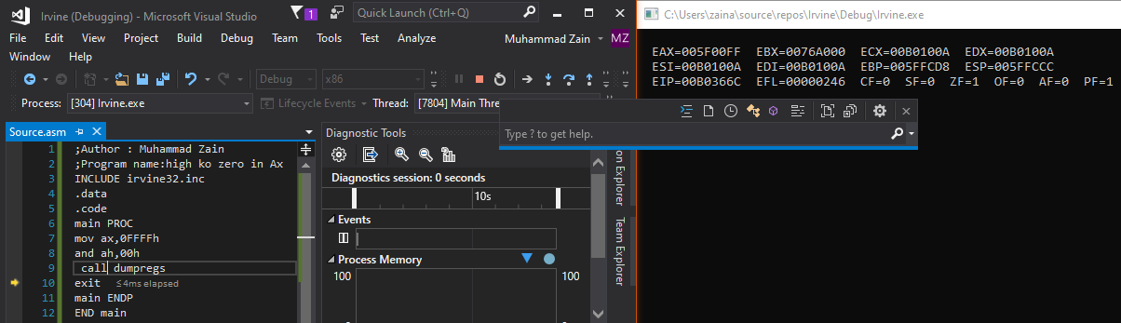

Task 3

# Source Code

;Author : Muhammad Zain

;Program name:(even odd) clear flag

INCLUDE irvine32.inc

.data

.code

main PROC

mov eax,22

and eax,1

call dumpregs

exit

main ENDP

END main

# Snip

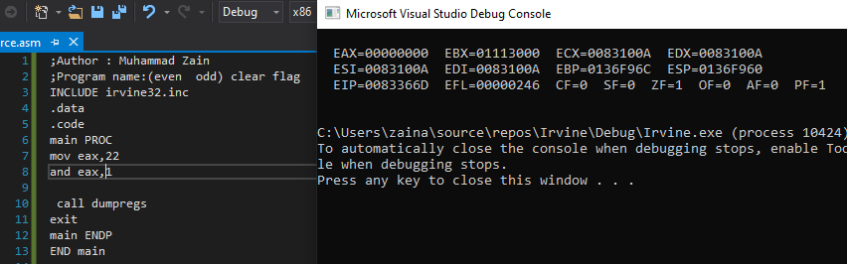

Task 4

# Source Code:

;Author : Muhammad Zain

;Program name:upper lower

INCLUDE irvine32.inc

.data

.code

main PROC

call readChar

or ax,32

call writeChar

call dumpregs

exit

main ENDP

END main

# Snip:

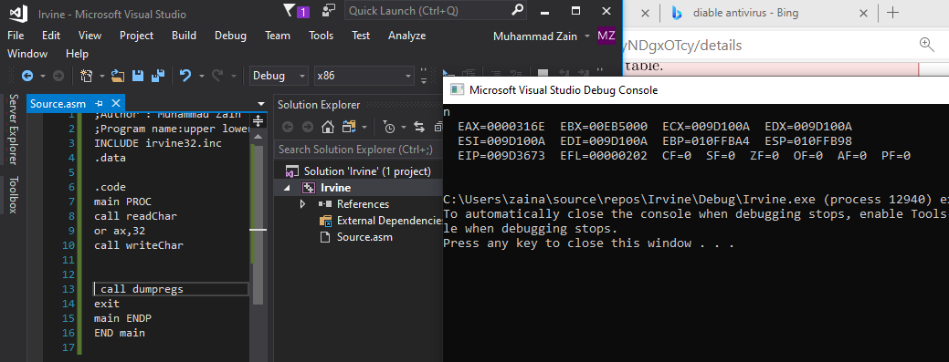

Task 6

# Source Code:

;Author : Muhammad Zain

;Program name:50 random numbers

INCLUDE irvine32.inc

.data

randomArray DWORD ?

count dword 0

.code

main PROC

mov ecx,50

mov esi,offset randomArray

L1:

call Random32

mov [esi],eax

mov eax,[esi]

call WriteInt

call Crlf

inc si

loop L1

mov ecx,50

mov esi,offset randomArray

L2:

mov edx,0h

cmp [esi],edx

jbe there

inc esi

jmp endLoop

there:

inc count

inc esi

endLoop:

loop L2

mov eax,count

call Crlf

call WriteInt

exit

main ENDP

END main

exit

# Snip:

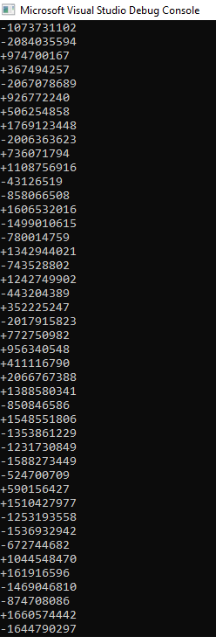

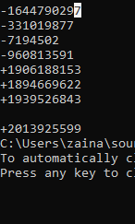

Task 7

# Source Code

;Author : Muhammad Zain

;Program name:revrse triangle

INCLUDE irvine32.inc

.data

num DWORD ?

Count DWORD 0

X DWORD 0

prompt DB "Invalid input , Try Again",0

.code

main PROC

read:

call ReadDec

jnc goodinput

mov edx ,OFFSET prompt

call writestring

call CRLF

jmp read

goodinput:

mov num,eax

mov X,eax

inc X

mov ecx,num

Loop1:

mov count ,ecx

mov ecx,X

;sub edx,ecx

neg cx

mov ecx,edx

loop2:

mov al,' '

call writechar

loop Loop2

mov ecx,count

Loop3:

mov al,'*'

call writechar

call CRLF

mov ecx,count

main endp

END main

exit